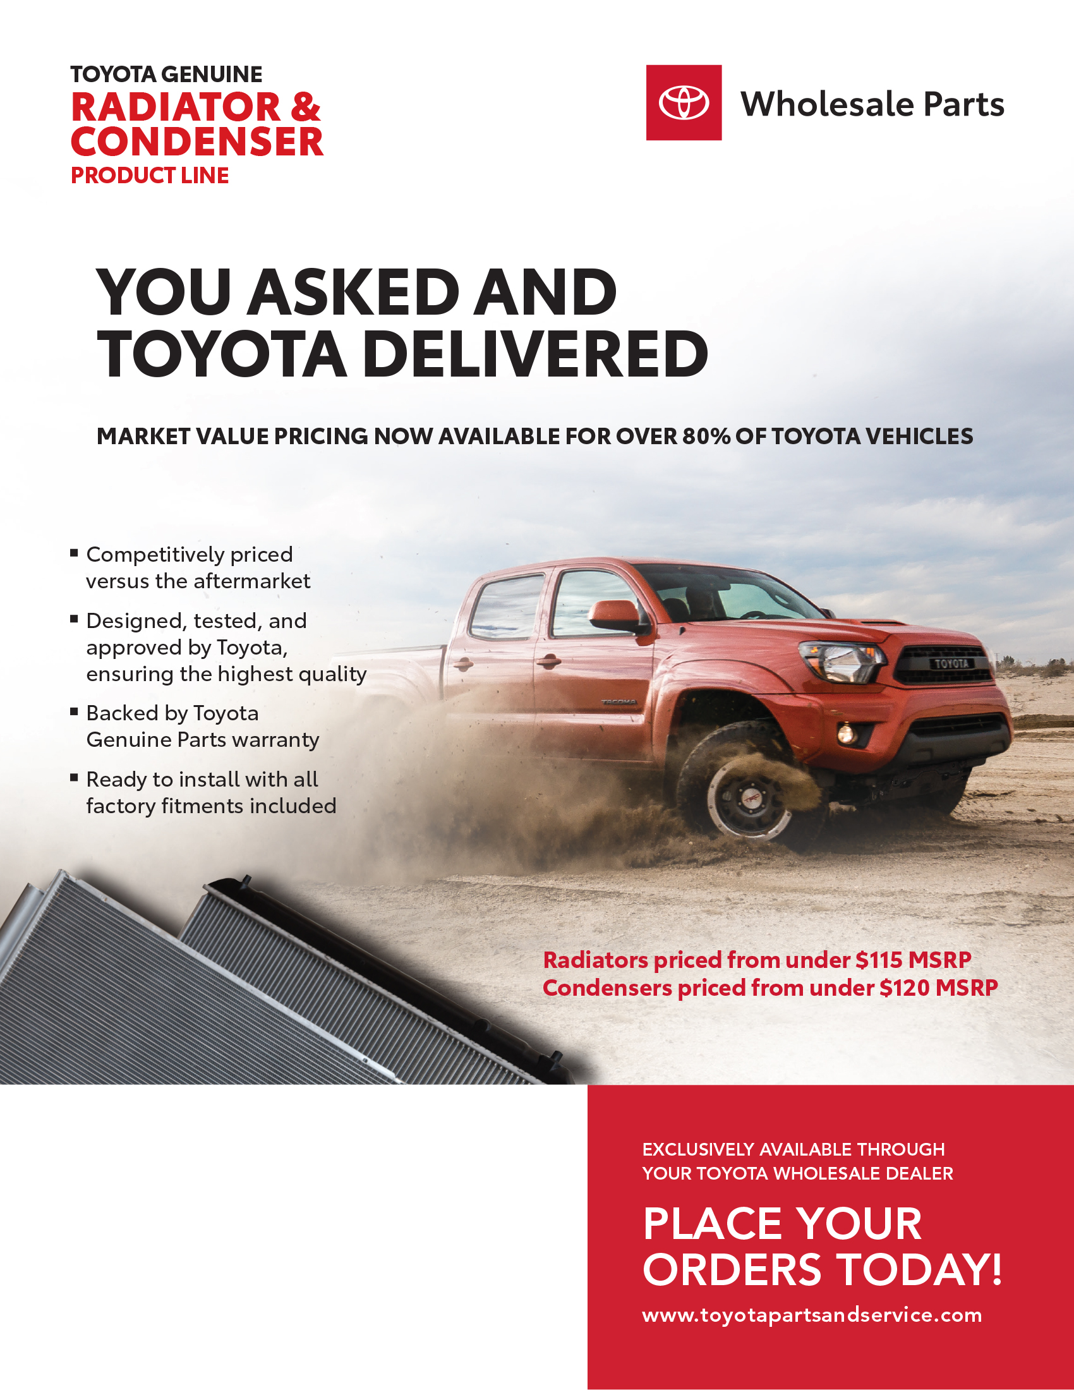

DEALERSHIP NAME

Contact Name

Phone Number